Lab 6: Kafka Producer and Consumer using .NET

Objective
To implement Kafka Producer and Consumer applications using .NET, send messages through a Kafka topic, receive them successfully, and verify the communication using console applications.

Commands Used
dotnet run

Producer/Program.cs
using Confluent.Kafka;
var config = new ProducerConfig
{
BootstrapServers = "localhost:9092"
};
using var producer =
new ProducerBuilder<Null, string>(config).Build();
Console.WriteLine("Kafka Producer Started");
while (true)
{
Console.Write("Enter Message : ");
string message = Console.ReadLine();
producer.Produce(
"chat-topic",
new Message<Null, string>
{
Value = message
});
Console.WriteLine("Message Sent");
}

Consumer/Program.cs
using Confluent.Kafka;
var config = new ConsumerConfig
{
BootstrapServers = "localhost:9092",
GroupId = "chat-group",
AutoOffsetReset = AutoOffsetReset.Earliest
};
using var consumer =
new ConsumerBuilder<Ignore, string>(config).Build();
consumer.Subscribe("chat-topic");
Console.WriteLine("Kafka Consumer Started");
while (true)
{
var result = consumer.Consume();
Console.WriteLine(
"Received : " + result.Message.Value);
}

ClientApp/Program.cs
using System;
using System.Windows.Forms;
namespace ClientApp
{
static class Program
{
[STAThread]
static void Main()
{
Application.Run(new Form1());
}
}
}

ClientApp/Form1.cs
using System;
using System.Windows.Forms;
namespace ClientApp
{
public partial class Form1 : Form
{
public Form1()
{
InitializeComponent();
}
private void btnSend_Click(object sender, EventArgs e)
{
MessageBox.Show(
"Message Sent to Kafka");
}
}
}

Output
Producer Output
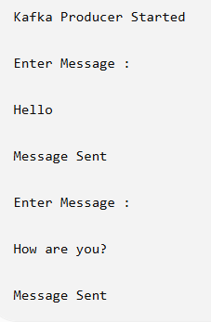
Consumer Output
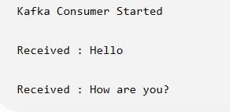

Result
The Kafka Producer successfully published messages to the 'chat-topic', and the Kafka Consumer received the same messages without errors. This demonstrates successful message communication between producer and consumer using Apache Kafka.

